**21.3.1**

**How many people work at the Company Company?**

In our office, there are 715 employees.

715 .cheers

How many people work at orther the office?

I think **There are 120000 people that work for the Company Company around the world.**

That’s a lot of people. We make 2000 products. So , we need a lot of people to make them and sell them.

2000 products. The Company Company must make a 100.000.000 dollars a year.

**They make a 1.000.000.000 dollars a year.**

A 1.000.000.000 dollars. The big boss must be rich

He is. He make 25.000.000 dollars a year. He need pay more money.

Yes. I would like 175.000 dollars a year.

I’d like 350.000 dollars a year.

Why waiting in line?

They _ email from Todd.

What email?

All employees need to meet and _ human resources to get and new ID card.Todd

What wrong with ID card?

They have old _

**Do all IDs have picture on them?**

**Most Ids have pictures on them:** Try with play some driver license, passport, work ID

**Do all employees have ID?**

I think most company make all employees get an ID

And most employees want a new picture on the ID

I know I do

Hi Aanya

Can I wait with you here?

I don't know. **Most people are mad when you cut in line**

Most people look at the phone when there in their line

At the start, what are Khae and Marco talking about?

-->How many people work at their company.

Why are Khae and Marco standing in line?

-->To get new ID cards.

Why do they have to get new ID cards ?

-->The picture are old.

When Aanya sees Khae and Marco , shee wants to get in line with them.

**Practice**

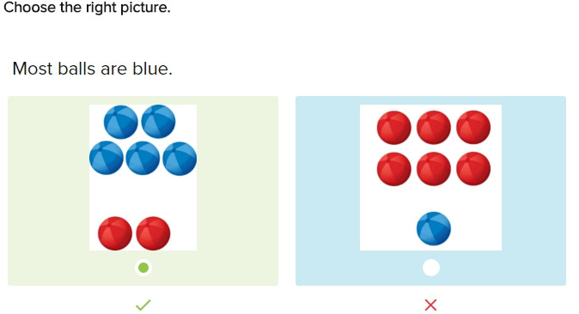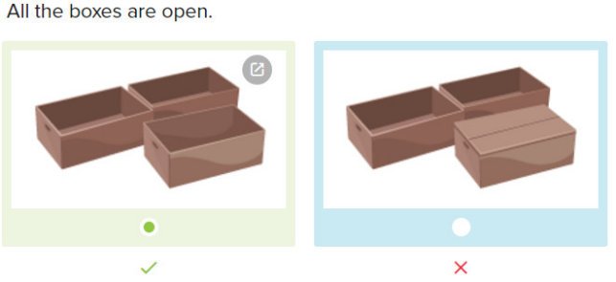

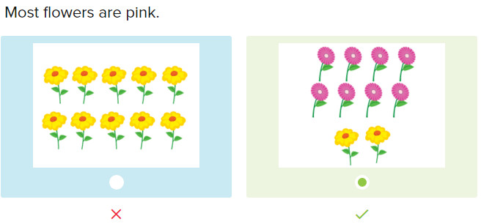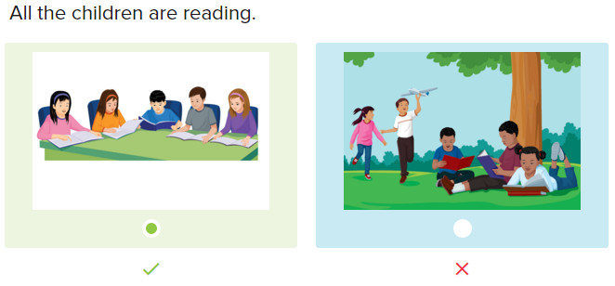

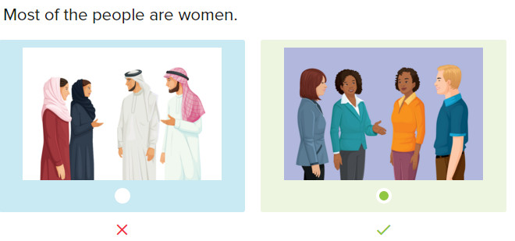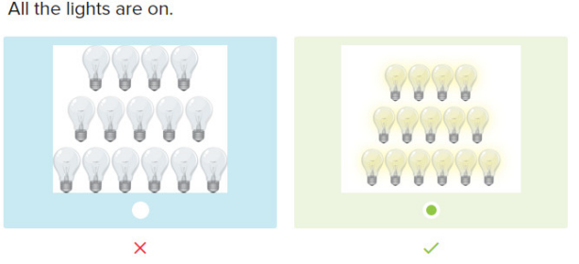

**Skills Practice**

The Healthy Ocean is a group that is trying to keep the ocean healthy. Do you know that the oceans take up more than half the world? There are 300,000 animals that live in the ocean. By the year 2050, we need to have more food to feed everyone. We need to eat more food from the ocean.

We can eat many fish from the ocean, but not all. Some fish can make people sick. These are not good fish to eat. Most fish are good to eat, and very healthy. Fish are over four hundred million years old. Fifty-one billion ocean animals are killed every year. We are trying to keep some kinds of fish alive and learn how to use the ocean as a place to get food. Right now, over one billion people need food from the ocean to stay alive.

How many different kinds of animals live in the ocean?

--> Three hundred thousand

How old are fish?

--> More than 400,000,000 years old

How many ocean animals are killed each year?

--> 51,000,000,000

How many people need food from the ocean to stay alive?

--> 1,000,000,000.

**Conversation**

Hi Ray, What do most people in your country do on the weekends?

Most people go to the mall on the weekends

Where are the mall?

Most mall are in the city

Are the mall open every day?

Yes, all mall are open every day. A few shops in the malls close on Sunday, but most are open

Oh, that’s cool. Do you know that famous shop, the big hat?

Yes, I do

Do you think most customer are men or women at the big hat?

I think most customer are men

Oh, that’s interesting. Which color hat do you think people like most?

Well, I think most men like black hats

Exercise

There are 300,00 different animals that live in the ocean

My boss makes 95,000 dollars a year

-> ninety-five thousand

The are 365 days in a year

-> three hundred and sixty-five

Do children like to eat cake?

-> Not every child likes cake, but most do.

3 out of 20 students have their homework. Most students do not have their homework

The restaurant sells 5,600 meals a day.

-> five thousand six hundred

The room needs to be dark. Please turn off all lights.

There are 7,200,000,000 people living on this Earth.

-->seven billion two hundred million

Every employee needs to buy a new hat tomorrow. All employees must bring money.

21.3.2

I want my ID photo to be good this time, my old ID have bad photo _

Most IDs have bad photos

There are bad

Are you telling me the trust?

He is right. Most photo IDs are bad. Look at Marco’s ID

Don’t laugh! Look at Khea’s ID

What’s wrong with Khea’s ID?

I don’t want you to see my ID

I saw Marco’s ID

And we saw Aanya’s ID, so what’s your ID?

Khae! Hello there, I’m Rima, _ Human resource, what’s your name?

My name Khae Jutathep. Nice to meet you

Nice to meet you Khae. I need to find your paper work

You can get my friend paper work too. Her name is Aanya Kuta

That's me

What's about me?

And my other friend name is Marco

I have them

Why do we need new IDs?

I don't know. It was Todd idea to make new IDs, so I'm taking everyone picture. Can you give me your old ID?

Here is this...What do I do now?

Seen the seance the wall on front the camera

That's a nice camera. Whose is it?

It's the Company Company's camera

I want the nice camera

My brother's camera is nice

Excute me, I need to take a picture

Oh, what do I do now?

Next, I need to take your picture. Look at the camera. 1 2 3

No, don't use that picture

I'm sorry, but only one picture for employee

Don't laugh

Aanya doesn't like her old ID photo because doesn't look good

Rima's office is messy

Why do the enployees need new IDs?

-> Todd wants new IDs

How does Khae feel about hẻ new ID card?

-> She is not happy.

Is this Nathan's office?

It isn't Mrs. Sampson's picture.

Glen's photo is old.

Look at Stephanie’s new ID.

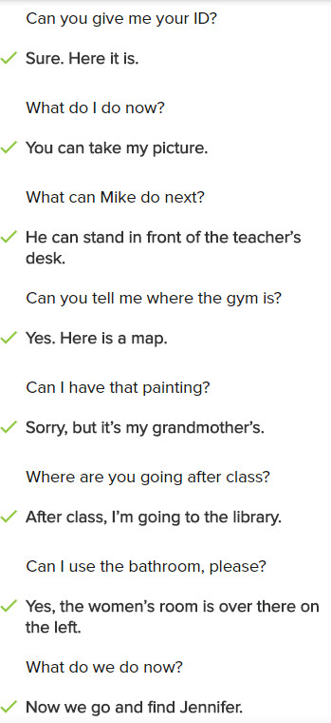

**Conversation**

Can you give me your ID?

Can you give me your old ID?

Here is it

Can I take your picture now?

Yes, you can. Where do I stand?

Could you stand in front of the wall, please?

Okay. What do I do now?

Stander and smile. Oh no, the camera is broken

Whose camera is it?

It’s the Company Company’s camera. What can we do now?

You can use this camera

Whose camera is it?

It’s Marco’s Camera

Oh, done. Is a anything else you need?

Yes, can I see the picture first?

**Exercise**

Can you give me John’s bag, please?

Is she the daughter of Mr.Miller?

-> Yes, she’s **Mr. Miller’s** daughter

My brother owns the computer

-> Oh! It’s your brother’s computer!

Can you give me that pencil?

-> Sure, here it is

Where can we get our new IDs?

-> You can get them from Rima’s office

What do I do now?

-> Please wait in front of the desk

How can you say “a picture of Ming Pei”?

-> Ming Pei’s picture

Can you give me your ID card?

-> No, I can’t

What does Lina need to do next?

-> She can go to the office now

21.3.3

Hi Anna, this is Mark. I can wait to see you in your family. Call me back, so we can plan the time to meet

Hi Mark, I hope we can find the time to meet. I don’t know know when you free. Hmm, I can meet on Monday between 12 and 3. Wednesday evening, I can meet any time after 5:30, and Thursday, I can any time before 2pm. Let’s me know your think! Bye

Anna, Mark again. I haven bad look with the phone, sorry I can take to you, but my cell phone isn’t work in here. So I think Wednesday is the best day for us. May be _ plan on dinner downtown. Do you know good restaurant and do you want to meet at the hotel? Call me back! Bye

Hi Mark! Yes, let’s me the hotel. Well, what about is 6 o’clock on Wednesday? You are the big mart right? There re a lot of great restaurant